# Exercise: CSS Box Model

Problems for exercises and homework for the ["HTML and CSS" course @ SoftUni](https://softuni.bg/courses/html-and-css). Submit your solutions in the SoftUni Judge system at <https://judge.softuni.bg/Contests/#!/List/ByCategory/134/HTML-and-CSS-Exercises>.

## Box Model Container

Create a web page like the following:

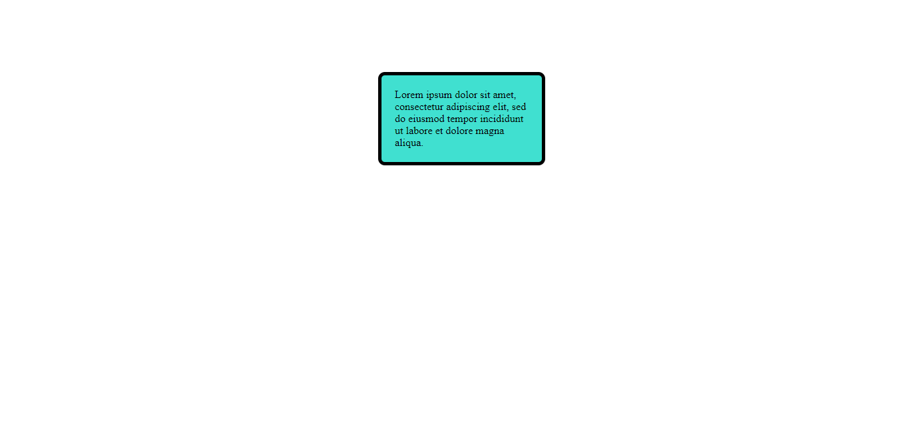

### Constraints

* Change the document **title** to "**Box Model Container"**
* Use p tag to create a paragraph
* Set the paragraph width: 200px;
* Set padding and margin
* Set 5px solid border with border-radius
* Use rgb(64, 224, 208) color for the background
* Try to center the container with margin: auto

## Box-sizing

Create a web page like the following:

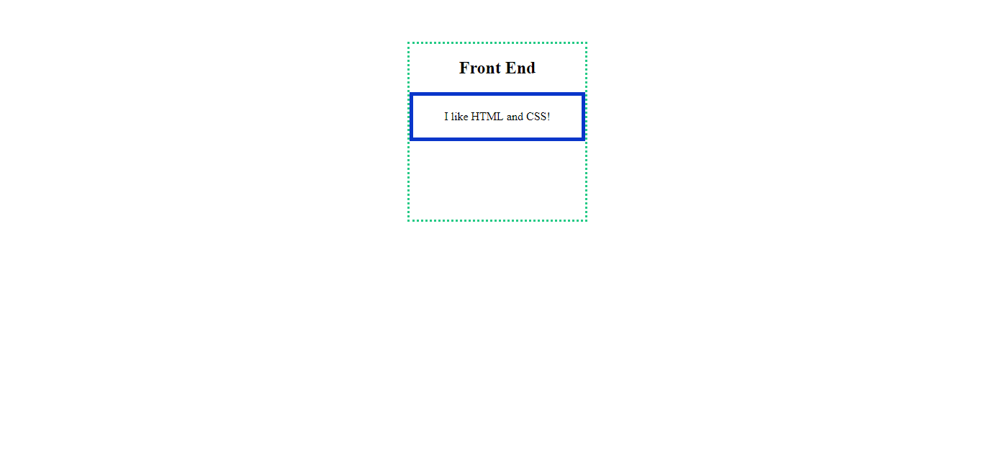

### Constraints

* Change the document **title** to "**Box Sizing"**
* Use section tag to create a section. In the section you have:
  + h1 heading with content "Front End"
  + **paragraph** with content "I like HTML and CSS! "
* The section has width 250px, height 250px and border
* The paragraph has width 100%, border and padding 20px on all sides

## Simple Article Page

Create a web page like the following:

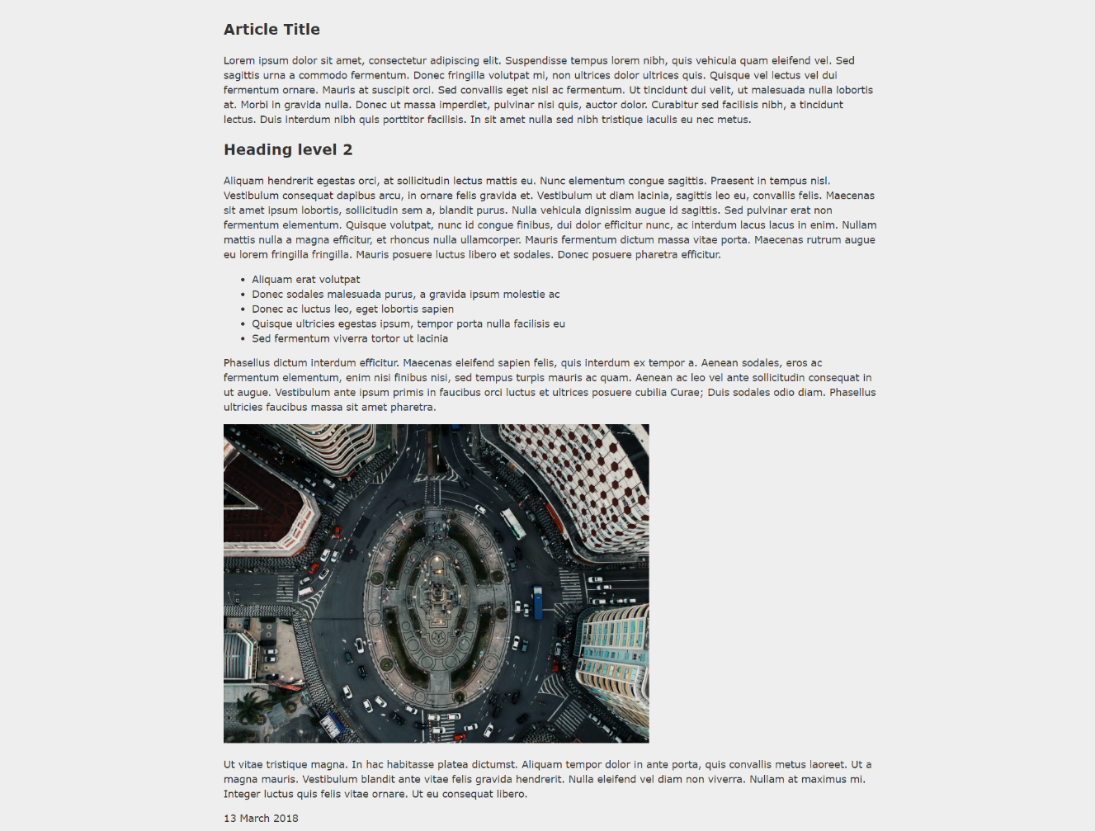

### Constraints

* Change the document title to "**Simple Article Page**"
* Use article tag to create an article
  + Divide the article content into header, section and footer tags
* Use background with color - rgb(238, 238, 238)
* Use rgb(51, 51, 51) color for the text

## Navigation Inline Block

Create a web page like the following:

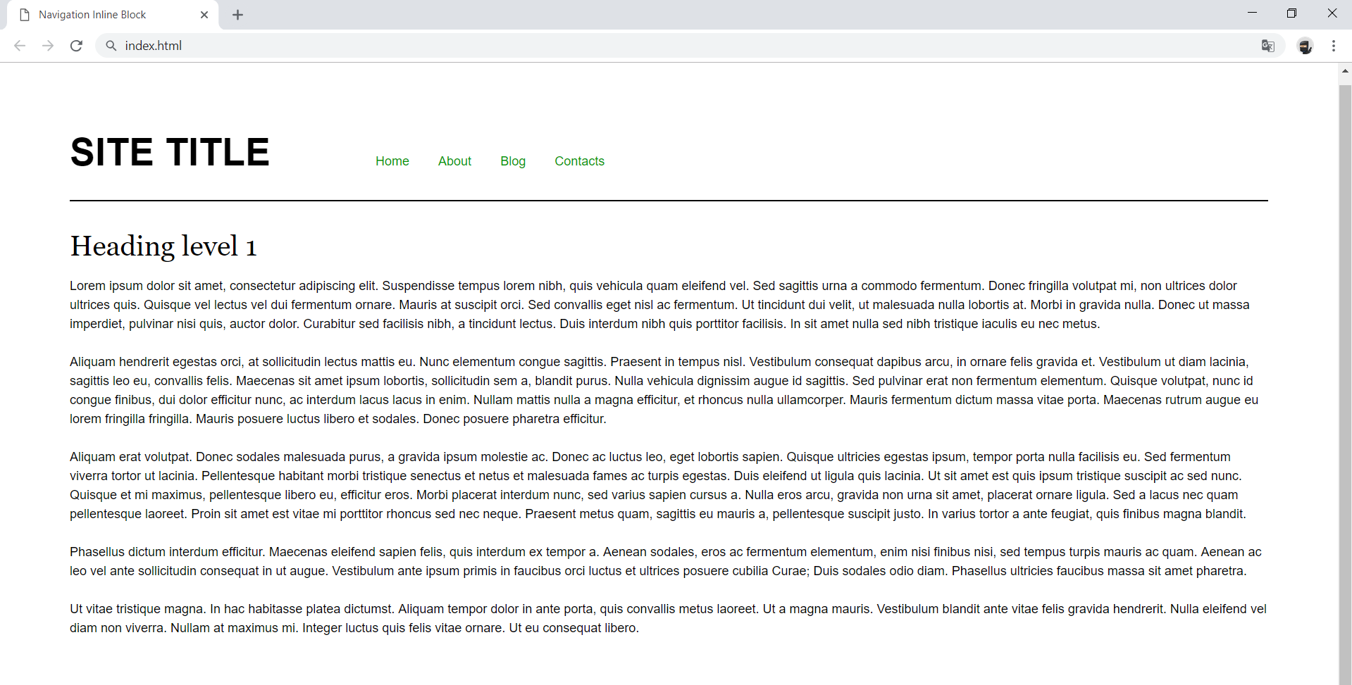

### Constraints

* Change the document title to "**Navigation Inline Block**"
* Divide your content into header and main tags
* Create a navigation bar
  + Add four list items in nav tag with a tags inside
  + Add display: inline-block; style for each item in the nav

## Photo Gallery Inline Block

Create a web page like the following:

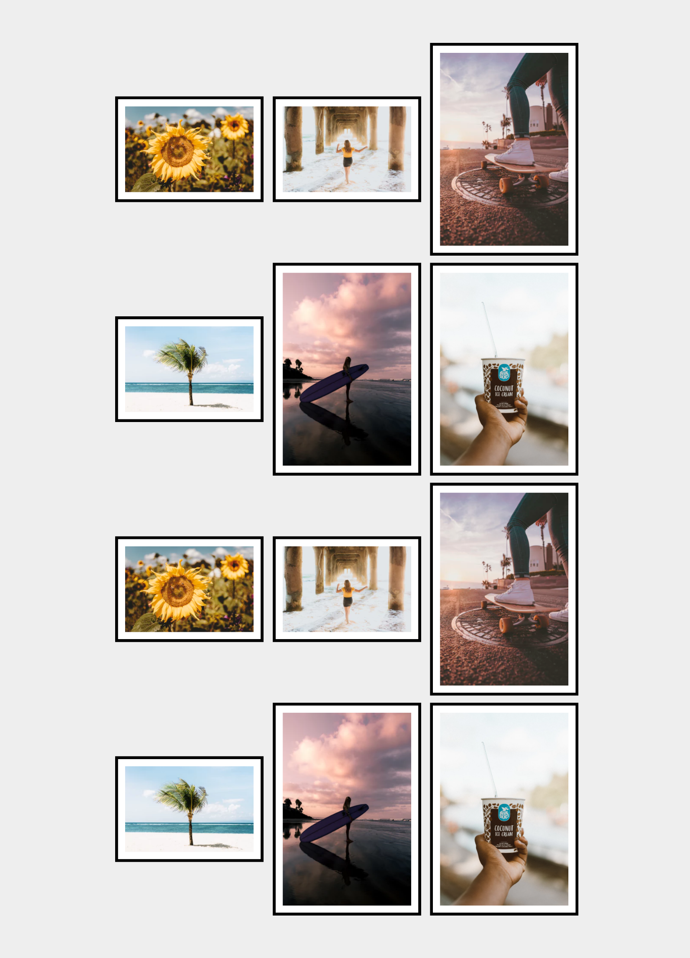

### Constraints

* Change the document title to "**Photo Gallery - Inline Block**"
* Create unordered list with class gallery (ul.gallery)
* Add list items with images inside
* The list items must have
  + Border width - 0.4rem
  + Border color - black
  + Border style - solid

## Blog Layout Inline Block

Create a web page like the following:

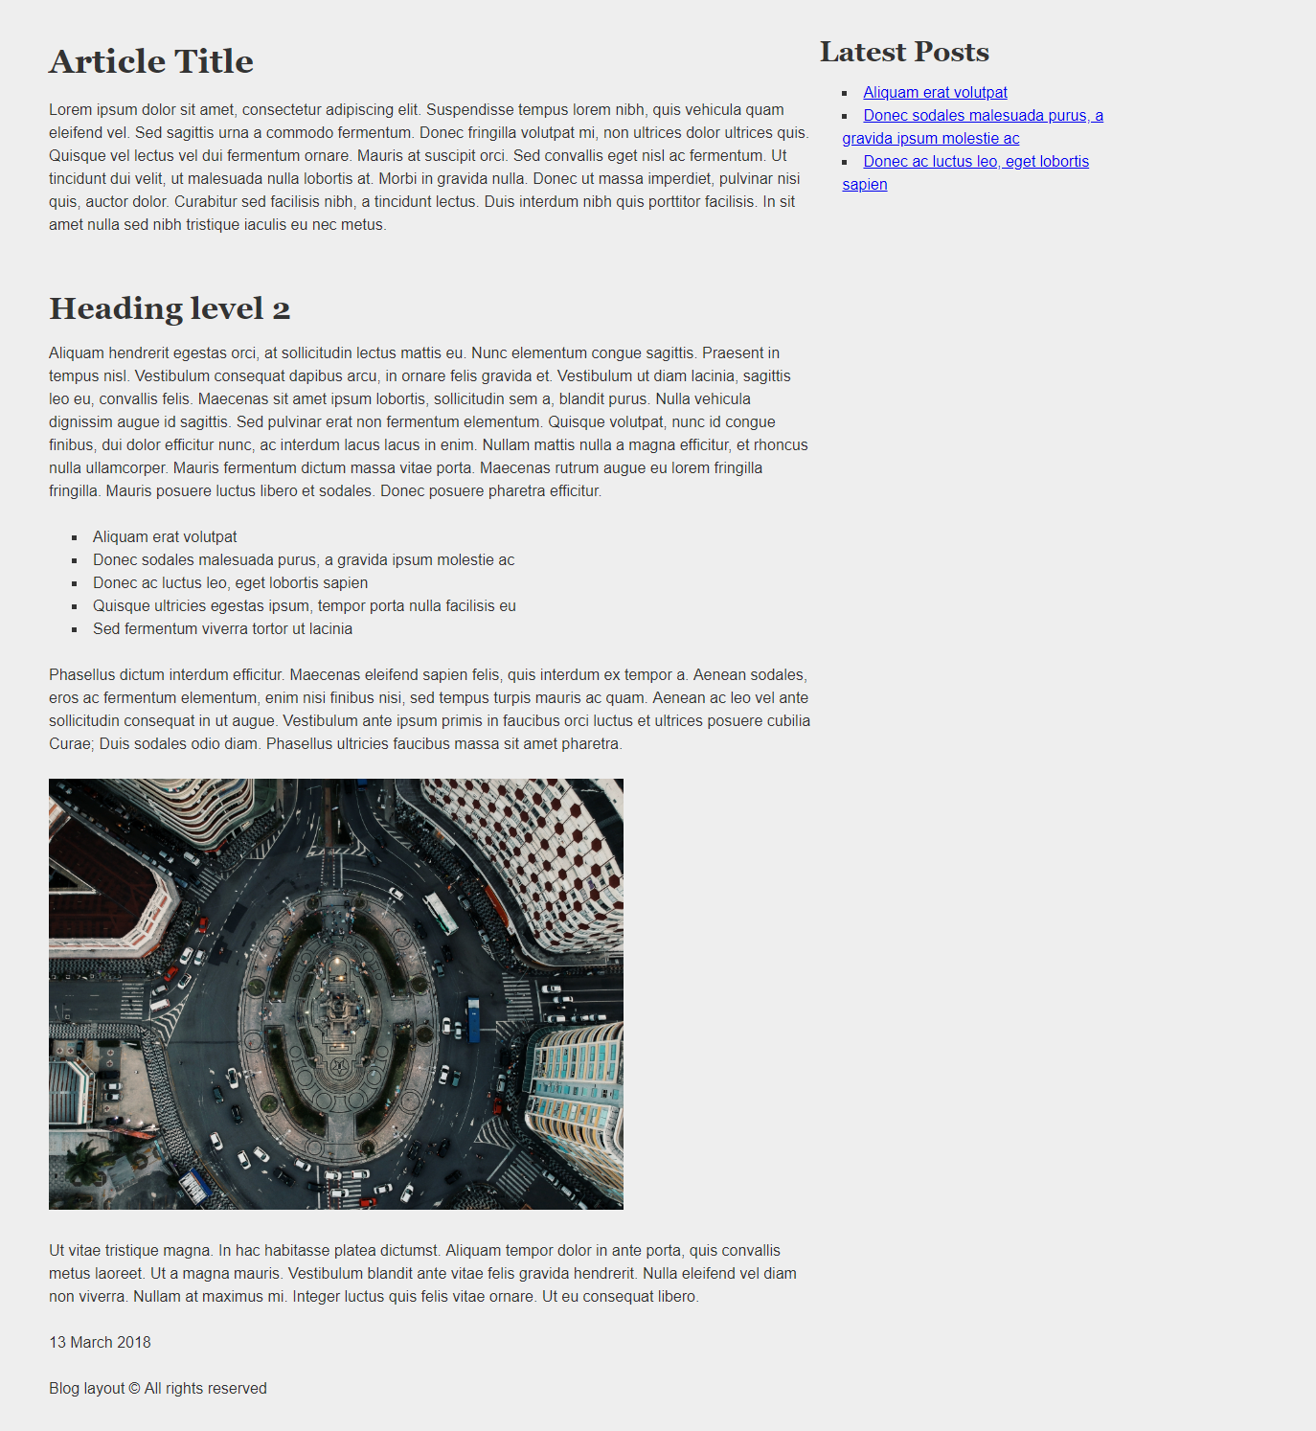

### Constraints

* Change the document title to "**Blog Layout Inline Block**"
* Use article tag to create an article
  + Divide the article content into header, section and footer tags
* Use aside tag to create aside for the **Latest** **Posts**
* Use background with color - rgb(238, 238, 238)
* Use rgb(51, 51, 51) color for the text